C:\Users\Small Miracles\AppData\Local\Microsoft\Windows\Temporary Internet Files\Content.IE5\2O6RX324\MC900286278[1].wmfC:\Users\Small Miracles\AppData\Local\Microsoft\Windows\Temporary Internet Files\Content.IE5\2O6RX324\MC900286278[1].wmf Small Miracles Preschool

Supply List 2020-2021

In order to keep our tuition cost down, parents are asked to donate the items listed below. Because we have limited storage space, the list has been divided according to your child’s classroom. Please refer to the list below to determine the supplies you are asked to bring. Please bring the supplies to the Parent Orientation Night, **Wednesday, September 2, 2020.** Pleasecomplete the form below and staple it to the bag of supplies. If you are unable to attend the Parent Orientation Night, please bring the supplies to the Preschool Office the **second week of school**.Please **do not** bring the supplies on the first day of school. We understand that some items may be difficult to find at this time.

**AM & PM PreK Classes**

**1 pack of 5oz. paper cups**

**1 roll of paper towels**

**1 refill hand soap**

**1 Elmer's Liquid School Glue**

**1 large Elmer's School Glue Stick**

(0.77 oz size)

**1 cannister Clorox Wipes**

**1 pack Crayola washable markers**

**1 box of 16 Crayola Crayons**

**1 box of Kleenex tissues**

**1 bottle Clorox Anywhere Cleaner**

**1 plastic pencil box**

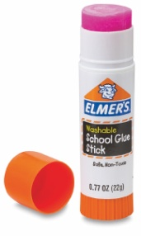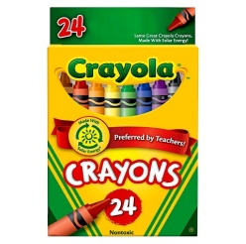

More optional supplies will be sent in our weekly newsletters!

* You may be asked to donate later in the school year to replenish items we use daily

------------------------------------------------------------------------------------------------------

(**Attach this portion to the bag of supplies**)

Child’s Name ________________________________________________

Child’s Class (please circle one)

PreK AM PreK PM